Setting up Application Environment CREATE FLASK PROJECT

|  |  |
| --- | --- |
| Team ID | PNT2022TMID26542 |
| Project Name | Personal Expense Tracker  Application |

**Step 1 :** Download Python from the official website. <https://www.python.org/downloads/>

Download and install python

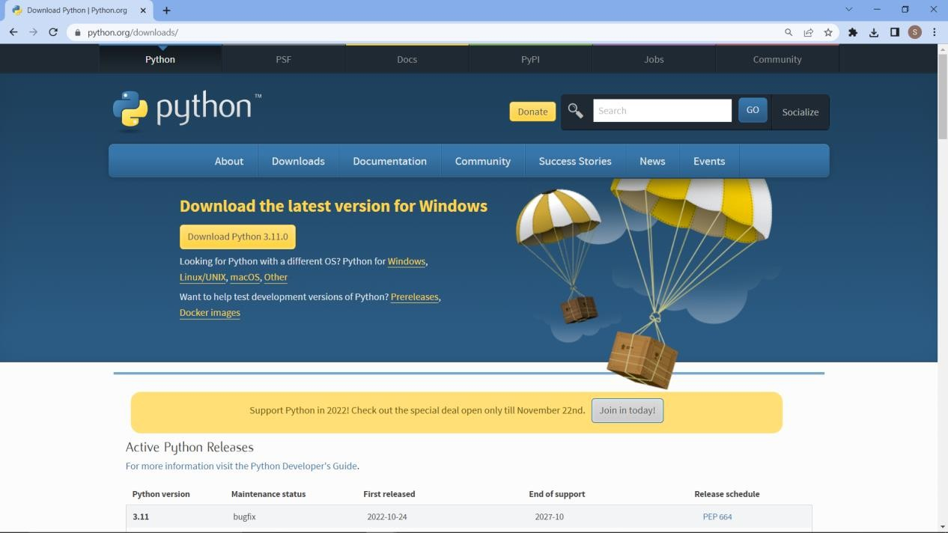

**Step 2:** Open command prompt and cross verify the versions.

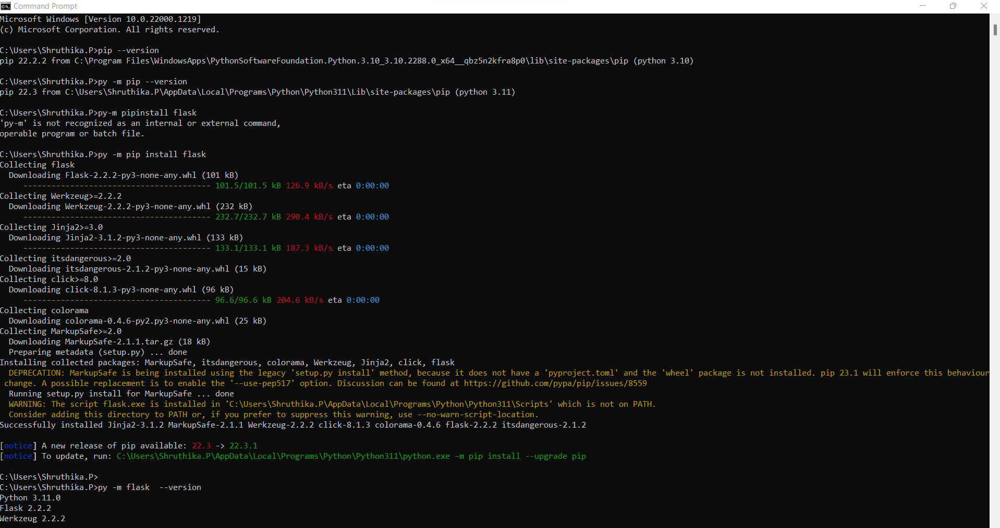

**Step 3 :**Checking Flask version

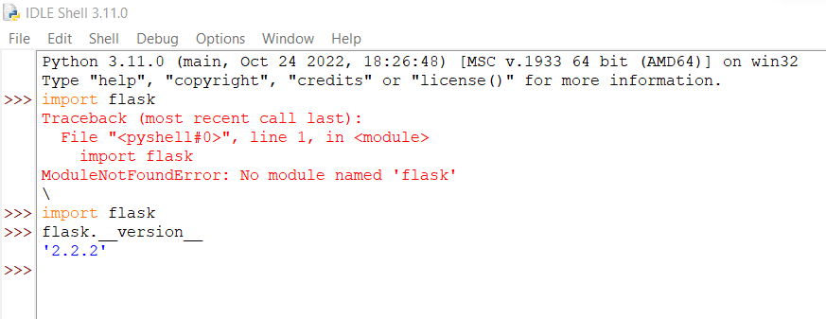

Step 4: Open new python file and start coding

from flask import Flask

app = Flask( name ) @app.route("/")

def home():

return "hi!"

**Step 4:** Run the program in cmd using the command python -m flask run

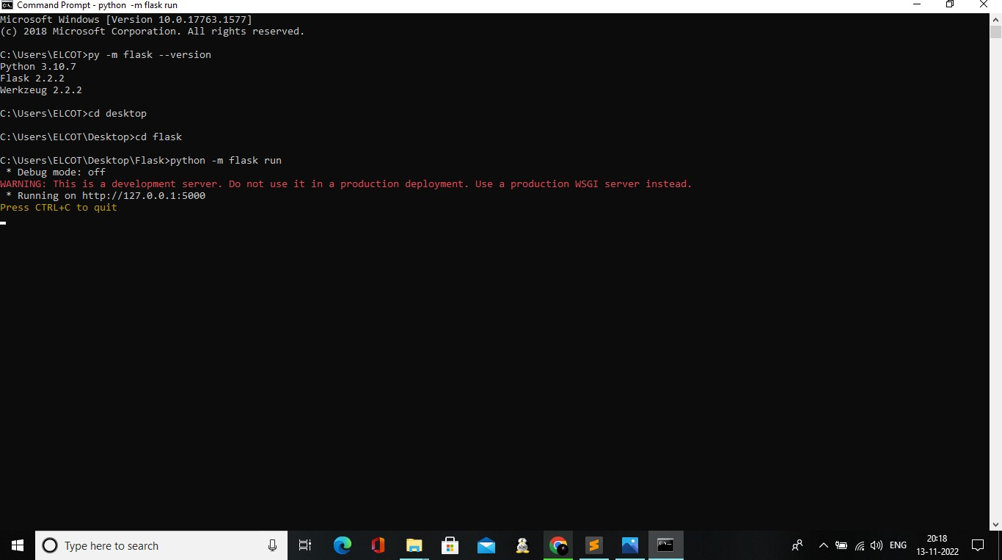

**Step 5:** Open the ip in browser

